## Part A

Notes:

1. First we create a simple struct and class based on three variabes.
2. After that we write values to bin file using io operations.

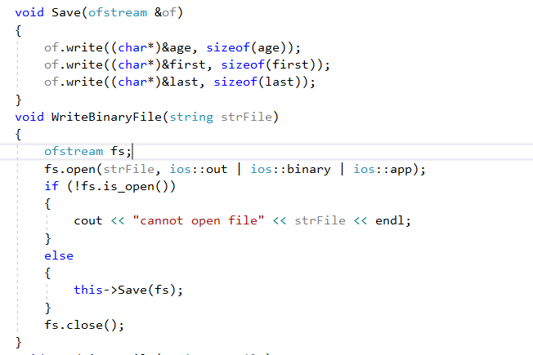

1. After opening a file we need to close it as in a broader context, that is thinking more widely than just C++ and fstream, when an output file is closed, any data remaining in the output buffer is written to the output file. If a file isn't closed properly, then some data may be missing from the file, or the file may be corrupted in some other way. But that's just background information.
2. After compiling and running the program you can see binary file in the project folder.
3. After that we read the data from the binary file and print it on console to check.

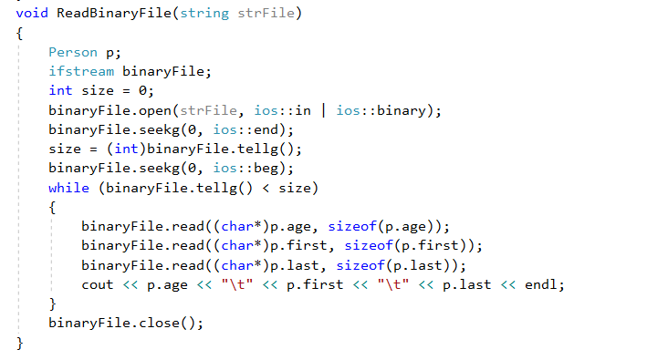

Read Binary



Output

# Part B

1. For this part we mainly read in a simple text file and start with just simply showing the output lines in the text files.

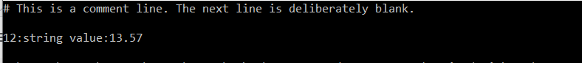

1. Next we modify the code so that it can now read the file and analyze and avoid comment lines and blank lines and additionally print split line to screen.

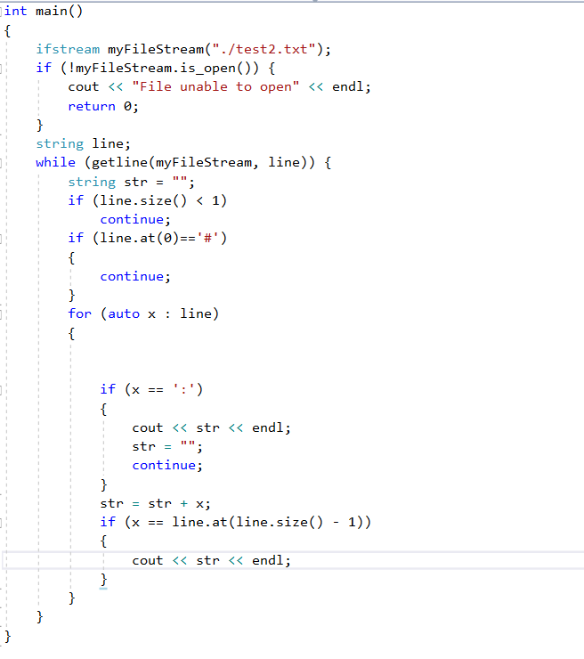



## Part C

1. First we download the nlohmann Json from github and place it in our project directory to make it easier to include in our project.
2. The we read in the json file and print the values to console.

